- Ensure that students can’t download files unless they register the course
- Create a table on the first page
Course name | Start Date | Time | Time Zone | Language | Enroll
Mastering Key Performance Indicators | 12-January 2026 | 6:30 pm | Saudi Arabia | English | Button
Strategic Talent Management | 26-January 2026 | 6:30 pm | Saudi Arabia | English | Button
Performance Management | 09-February 2026 | 6:30 pm | Saudi Arabia | English | Button

In the next session, we will work together to develop a Strategic Talent Management course from Scratch and make a recording.
Place Counter

- Develop a very nice page where I could place video links, as I showed you
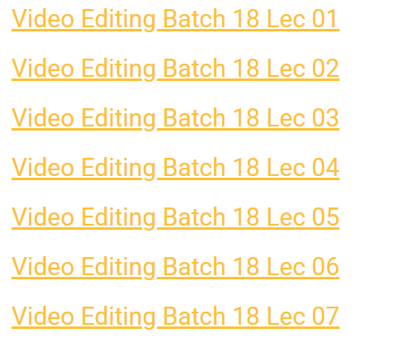
Develop the mechanism to download or save my training sessions on my External Hard Desk.

Please add your more creativity to make this page more attractive.


All courses price should be $100

Chart and Cart icons are overlapping. Whatapp pop up disappeared. Please organize accordingly.
Refine Competency pages as you explain to make more attractive (maybe in word documents).
Remove the word “teaching” showing in the job description page.
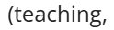

HR Policies Section
Change from my to your

Add social medi icons

